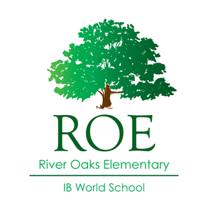**River Oaks Elementary**

**2008 Kirby Dr. Houston TX 77019**

Principal: Brett Gallini

Welcome to River Oaks Elementary School

It is my pleasure to welcome the River Oaks Elementary community to the 2022-2023 school year and celebrate our 94th year in the community. We are a community of learners with deep traditions and our work is to guide our students to become creative inquirers who take action.

Our school has a strong academic program, our staff is resolute, and our families offer a level of support that is unparalleled. River Oaks is a Vanguard Magnet School for Gifted and Talented Students as well as an International Baccalaureate World School, we embrace students wherever they are in their learning journey. These two programs work together to ensure that every student’s academic experience is through the lens of inquiry and build strong character.

Thank you for the very warm welcome. It is my honor and pleasure to lead such a wonderful school and continue our tradition of excellence for all students.

Warmly,

Brett Gallini

Principal Bio

Brett Gallini began his teaching career as a fifth-grade teacher more than two decades ago and prior to coming to Texas has worked in the two largest urban school districts in the country, Los Angeles Unified School District, and the New York City Department of Education. Mr. Gallini has held multiple teaching and leadership positions at the school and district level. He is most enthusiastic about the role of school principal and loves collaborating with teachers, students, and families.

Outside of work Mr. Gallini is a husband and father to two small children. He enjoys traveling, physical exercise and spending time with his family.